Research Article
Hierarchical coverage and capacity optimization of 5G New Radio non-standalone networks in a hilly tourism corridor
Abstract
This study develops and evaluates a staged strategy for optimizing fifth-generation (5G) New Radio (NR) non-standalone (NSA) network performance in a hilly tourism corridor with transient, high-mobility users. A drive-test campaign on a commercial network in the Jam Gadang corridor, Bukittinggi, Indonesia, generated 7,522 raw records; after network-mode filtering and quality screening, 367 5G-specific samples were retained. An Atoll planning baseline configured from the available as-built project parameters was then used to compare three interventions with increasing hardware intensity: antenna tilt and azimuth tuning, small-cell densification, and addition of a macro-site. Field measurements showed that 97.55% of RSRP samples were in the very-good band, whereas only 0.54% of downlink-throughput samples were very good, indicating that capacity and radio-quality limitations were more prominent than basic signal-strength coverage. In the simulation baseline, the very-good shares were 77.30% for RSRP, 70.55% for SINR, and 93.40% for downlink throughput. Antenna tuning increased very-good RSRP to 84.50% and reduced poor SINR from 2.03% to 0.06%. Small-cell densification produced the highest simulated very-good throughput share (99.00%), while the new macro-site produced the highest very-good RSRP share (92.20%) and eliminated the poor RSRP band. Because the field and model data were not formally calibrated and did not use fully frequency-matched configurations, the simulation is interpreted as a controlled scenario-comparison tool rather than a direct replica of measured performance. The results support a practical hierarchy in which low-hardware reconfiguration is attempted before targeted densification and new-site deployment.
Keywords: 5G NR NSA, Antenna optimization, Drive test, Radio network planning, Small cells, Tourism corridor
1. Introduction
Fifth-generation mobile systems are being deployed through both standalone and non-standalone architectures, and the performance experienced by users depends not only on nominal coverage but also on interference, load, propagation conditions, and radio-access configuration [1-7]. For commercial 5G NSA networks, field measurements remain important because application-layer throughput and radio-quality indicators can vary substantially even when signal strength is adequate [3-7]. This distinction is especially relevant in tourism corridors, where short-term visitor concentrations and mobility can produce a capacity problem without creating an obvious RSRP coverage deficit.
Radio-network optimization can be approached through several levels of intervention. Parameter changes such as antenna tilt and azimuth can alter cell footprint and interference without adding new radio sites, whereas small-cell densification can increase local capacity and a new macro-site can extend or reinforce coverage [8-15]. These interventions differ in hardware requirements and operational complexity. Consequently, a staged planning process is preferable to adding infrastructure before confirming whether lower-intensity configuration changes are sufficient. Energy and sustainability considerations further support avoiding unnecessary site additions, although a complete techno-economic or energy model is required before monetary or energy savings can be quantified [16,17].
Complex terrain creates an additional planning challenge because shadowing, clutter, elevation changes, and antenna geometry can produce local variations that are not captured well by generic planning assumptions [8,18-21]. Empirical studies of 5G NSA networks have also shown that throughput and service continuity depend on more than one radio metric [6,7]. Therefore, comparisons between field measurements and planning simulations should distinguish measured user experience from model-based predictions and should not be described as calibrated unless a formal model-tuning procedure has been performed.
The present study addresses this problem using a commercial 5G NSA deployment in the Jam Gadang tourism corridor of Bukittinggi, West Sumatra. Its contribution is threefold: it provides field evidence from a hilly, high-mobility tourism setting; it compares three radio-planning interventions against the same Atoll baseline; and it organizes the interventions into a practical hierarchy based on hardware intensity. The study does not claim a formal cost-benefit analysis; rather, it uses the amount of additional radio infrastructure as a planning-order criterion.
The study addresses four research questions: (RQ1) Which measured KPI is the main limitation in the corridor: signal-strength coverage, radio quality, or downlink throughput? (RQ2) How does the Atoll baseline compare with the field measurements, and what limits direct equivalence between the two data sources? (RQ3) How do antenna tuning, small-cell densification, and new macro-site addition change the simulated KPI distributions when evaluated from the same planning baseline? (RQ4) What staged optimization strategy is supported by the combined field and simulation evidence?
2. Materials and methods
2.1 Study design and study area
A quantitative empirical and simulation-based design was used. Field measurements were combined with controlled radio-planning scenarios so that the measured network condition could identify the dominant operational limitation, while the simulation could compare alternative planning interventions under a common model setup. The study area was the Jam Gadang corridor in Bukittinggi, West Sumatra, Indonesia. Bukittinggi covers approximately 25.24 km² and is characterized by hilly terrain at approximately 900-1,000 m above sea level. The corridor contains concentrated commercial and tourism activity and a large proportion of transient users, making it appropriate for evaluating coverage-quality and capacity trade-offs.
Field measurements were taken in the service areas of two Telkomsel gNodeBs identified in the project material as Site Plaza and Site Toko Sehati. The measured commercial service used a 5G NR NSA configuration in the n1 band (2100 MHz) with LTE anchors reported as L1/L3/L8. Geographic coordinates were referenced to WGS84 and projected to UTM Zone 48S. Terrain and clutter information used in the planning environment included a 30 m digital elevation model and building-context information from Google Earth Pro.
2.2 Drive-test acquisition and data screening
The drive test was conducted with G-NetTrack Pro v.30.5 on a smartphone capable of operating on the 5G n1 band. The SIM card was configured for the Telkomsel 5G service, and measurements were collected along the Jam Gadang, Pasar Ateh, and Site Toko Sehati corridors at a vehicle speed of approximately 20-30 km/h. The recorded variables were reference signal received power (RSRP, dBm), reference signal received quality (RSRQ, dB), signal-to-interference-plus-noise ratio (SINR, dB), downlink throughput (TPUT-DL, Mbps), and GPS/time information.
A total of 7,522 raw records were obtained. Network-mode filtering excluded 7,155 records that were not tagged as 5G NR, leaving 367 5G-specific records (4.88%). The retained subset was then checked for missing KPI values, exact duplicate coordinate/KPI records, and points outside the defined corridor boundary. The final analytical dataset remained 367 records. Downlink throughput was measured by an active 100 MB random-byte download from a TestMy.net server while the drive-test log was running. Measurements were collected from 10:08:28 to 10:50:30 on 2 February 2026 during the locally defined peak-visitor period.

2.3 Atoll baseline and optimization scenarios
The planning baseline was reconstructed in Atoll from the project configuration available to the authors. Cost-Hata, Okumura-Hata, and 3GPP TR 38.900 propagation-model options were retained as recorded in the project material. Importantly, no post-hoc propagation-model tuning was performed to minimize error against the drive-test data. Therefore, the baseline is described as configured from as-built/project parameters rather than calibrated. The field measurements and Atoll outputs were compared descriptively at the level of KPI band shares.
Table 1 Atoll configuration parameters used for the baseline and optimization scenarios
Parameter | Configuration used in the project material
Propagation models | Cost-Hata, Okumura-Hata, and 3GPP TR 38.900 across the baseline and scenarios.
Transmit power | 50 (unit not specified in the source configuration table).
Antenna gain | 17 dBi for all configurations.
Antenna height | Plaza: 21 m before; 21-22 m final. Toko Sehati: 17 m. New macro-site: 30 m. Small cell: 10 m.
Tilt and azimuth | Plaza before: 0°, 100°, 180°; mechanical tilt 2°-6°. Final azimuths: 20°, 85°, 110°, 145°, 230°, 250°, 305°; tilt 2°-6°. Toko Sehati before: 90°, 160°, 315°; tilt 0°-4°. Final azimuths: 15°, 90°, 130°, 145°, 180°, 235°, 275°, 320°, 345°; tilt 2°-4°.
Bandwidth/bands | Plaza: n3 20 MHz and n8 10 MHz. Toko Sehati: n40 20 MHz and n3 20 MHz. New macro-site: n3 20 MHz and n8 10 MHz. Small cell: n8 10 MHz and 5 MHz.
Added infrastructure | One small cell at 100.373335328° E, 0.310867453° S; one new macro-site at 100.36811° E, 0.30618° S.
The field and simulation configurations were not fully frequency matched: the drive-test description identifies 5G NR n1, while the Atoll project export records n3/n8/n40 entries for the modeled sites and added infrastructure. This difference, together with the absence of formal propagation calibration and live-traffic modeling in Atoll, prevents direct point-by-point validation. The Atoll outputs are therefore used only to compare the relative effect of three controlled planning scenarios: Scenario A, antenna tilt and azimuth tuning without added radio sites; Scenario B, addition of one small cell at the identified hotspot; and Scenario C, addition of one macro-site to address residual predicted coverage gaps.
2.4 KPI classification and comparative analysis
Field samples and simulation outputs were summarized using the operator-category thresholds available in the source analysis. To avoid ambiguity at shared category boundaries, the intervals are written below as mutually exclusive ranges while preserving the original cut-off values. The field dataset was summarized as the percentage of retained samples in each category. The simulation was summarized as the percentage of predicted pixels/area elements in each category. These percentages are different statistical units and were not treated as paired observations.
Table 2 KPI category thresholds used in the analysis
Category | RSRP (dBm) | RSRQ (dB) | SINR (dB) | TPUT-DL (Mbps)
Very good | ≥ -85 | ≥ -10 | 10 to 30 | 14 to 20
Good | -92 to < -85 | -14 to < -10 | 3 to < 10 | 7 to < 14
Fair | -102 to < -92 | -17 to < -14 | 0 to < 3 | 1 to < 7
Poor | -120 to < -102 | -25 to < -17 | -20 to < 0 | 0.512 to < 1
No inferential hypothesis test was applied. The analysis focused on descriptive KPI distributions and scenario-to-baseline changes. "Very good" share was used as an indicator of the proportion of observations or modeled area meeting the strongest quality band, whereas "poor" share was used to identify residual weak-service areas. The staged recommendation was based on the direction and magnitude of KPI changes together with the relative amount of additional hardware required; it is not a monetary cost model.
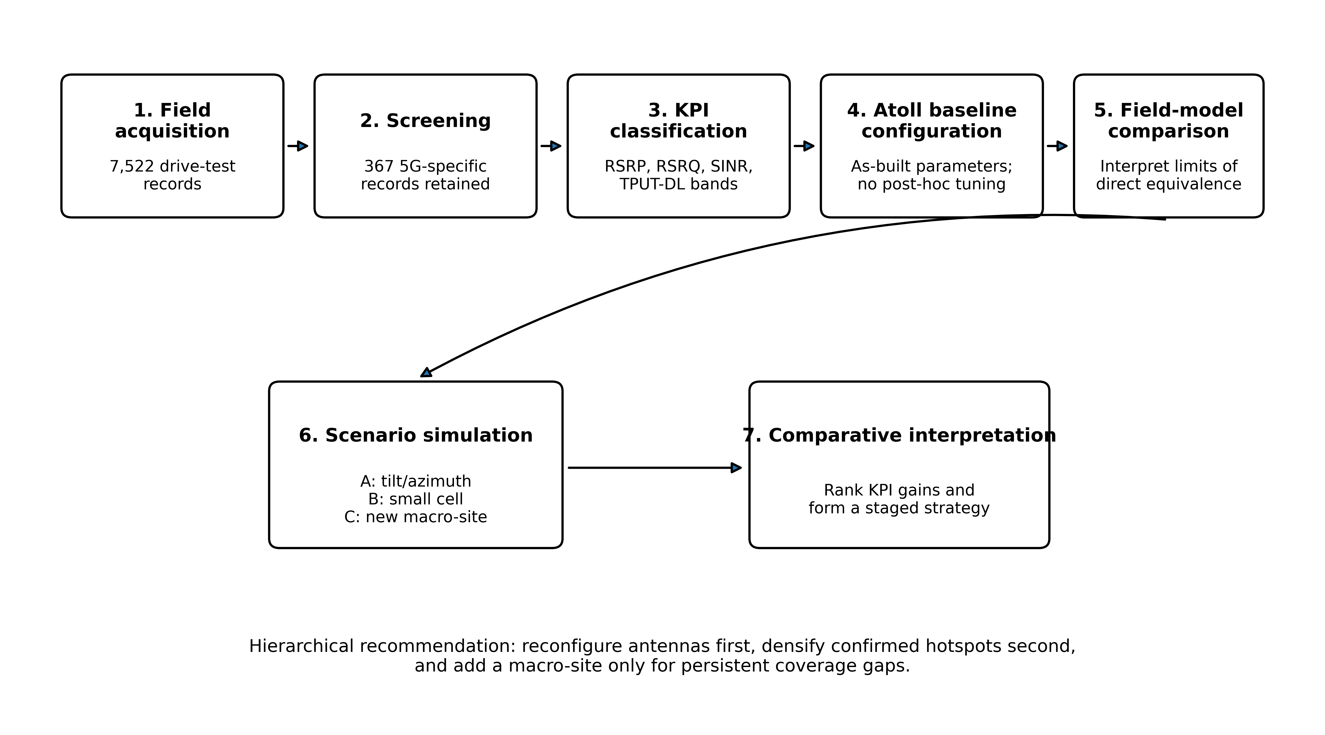
Figure 1 Study workflow from field acquisition to controlled scenario comparison and hierarchical interpretation.
3. Results and discussion
3.1 Field-measured network performance
Among the 367 retained 5G-specific samples, RSRP was predominantly in the very-good category (97.55%), indicating that signal-strength coverage along the measured route was generally strong. RSRQ was concentrated in the good category (95.64%). SINR showed a wider distribution: 46.32% of samples were very good, 37.33% were good, 11.44% were fair, and 4.90% were poor. Downlink throughput was the weakest measured KPI: only 0.54% of samples were in the very-good band, 38.42% were good, 31.06% were fair, 0.27% were poor, and 29.70% had no traffic/N/A. These results indicate that the principal field limitation was not basic RSRP coverage but the ability to translate radio conditions into consistently high downlink performance.
Table 3 Drive-test KPI category distribution (n = 367 5G-specific samples)
Category | RSRP (%) | RSRQ (%) | SINR (%) | TPUT-DL (%)
Very good | 97.55 | 1.36 | 46.32 | 0.54
Good | 2.45 | 95.64 | 37.33 | 38.42
Fair | 0.00 | 2.72 | 11.44 | 31.06
Poor | 0.00 | 0.27 | 4.90 | 0.27
No traffic / N/A | — | — | — | 29.70
The separation between strong RSRP and much weaker throughput is consistent with empirical studies showing that 5G NSA user performance is affected by SINR, dual-connectivity behavior, network load, handovers, and radio configuration rather than by received power alone [3,6,7]. The finding also argues against using RSRP as a single proxy for service quality in a tourism corridor with rapidly changing demand.
3.2 Field-to-model baseline comparison
The Atoll baseline predicted very-good shares of 77.30% for RSRP, 70.55% for SINR, and 93.40% for TPUT-DL. The corresponding poor shares were 8.90%, 2.03%, and 0.23%. The field and model results therefore do not constitute a calibrated match. Field RSRP was substantially stronger than the modeled RSRP distribution, field SINR was weaker than the modeled SINR distribution, and the largest discrepancy occurred for throughput: only 0.54% of measured samples were very good compared with 93.40% of the modeled area.
This discrepancy is expected from the way the two data sources were generated. The field throughput values were application-layer downloads measured under actual peak-period contention, whereas the Atoll throughput output represents a planning prediction that does not reproduce the same instantaneous traffic demand. In addition, the field description and simulation export are not frequency matched. For these reasons, the baseline is suitable for internal scenario comparison but not for claiming point-by-point prediction accuracy. Formal calibration would require geographically matched samples and an error criterion such as mean error, mean absolute error, or standard deviation after propagation-model tuning.
3.3 Effects of the three optimization scenarios
Scenario A, which changed antenna tilt and azimuth without adding a new site, increased the simulated very-good RSRP share from 77.30% to 84.50%, SINR from 70.55% to 77.85%, and TPUT-DL from 93.40% to 96.30%. The poor SINR share decreased from 2.03% to 0.06%, while poor RSRP remained 8.90%. This result supports antenna reconfiguration as a logical first intervention because it improved all three modeled KPIs without additional radio-site hardware. Antenna-tilt optimization has likewise been shown to alter coverage, interference, and energy-related network performance [13,14].
Scenario B, one small-cell addition, produced the highest modeled very-good throughput share (99.00%) and increased very-good SINR to 85.35%. However, the very-good RSRP share decreased to 75.04% and poor RSRP increased to 10.78%. The result should therefore be interpreted as a capacity-oriented local densification outcome rather than as a universal coverage improvement. Small-cell studies similarly show that densification can improve local bitrate and capacity while requiring careful interference and border-area management [9,15].
Scenario C, one new macro-site, produced the strongest modeled coverage result: very-good RSRP reached 92.20%, very-good SINR reached 85.40%, and the poor RSRP band was eliminated (0.00%). Very-good TPUT-DL reached 98.40%. This pattern is consistent with the role of additional macro infrastructure in resolving residual geometric or shadowing-related coverage gaps, particularly in terrain-sensitive deployments [8,10-12].
Table 4 Very-good band share for the Atoll baseline and optimization scenarios
Scenario | RSRP (%) | SINR (%) | TPUT-DL (%)
Baseline | 77.30 | 70.55 | 93.40
Scenario A: antenna tuning | 84.50 | 77.85 | 96.30
Scenario B: small cell | 75.04 | 85.35 | 99.00
Scenario C: new macro-site | 92.20 | 85.40 | 98.40
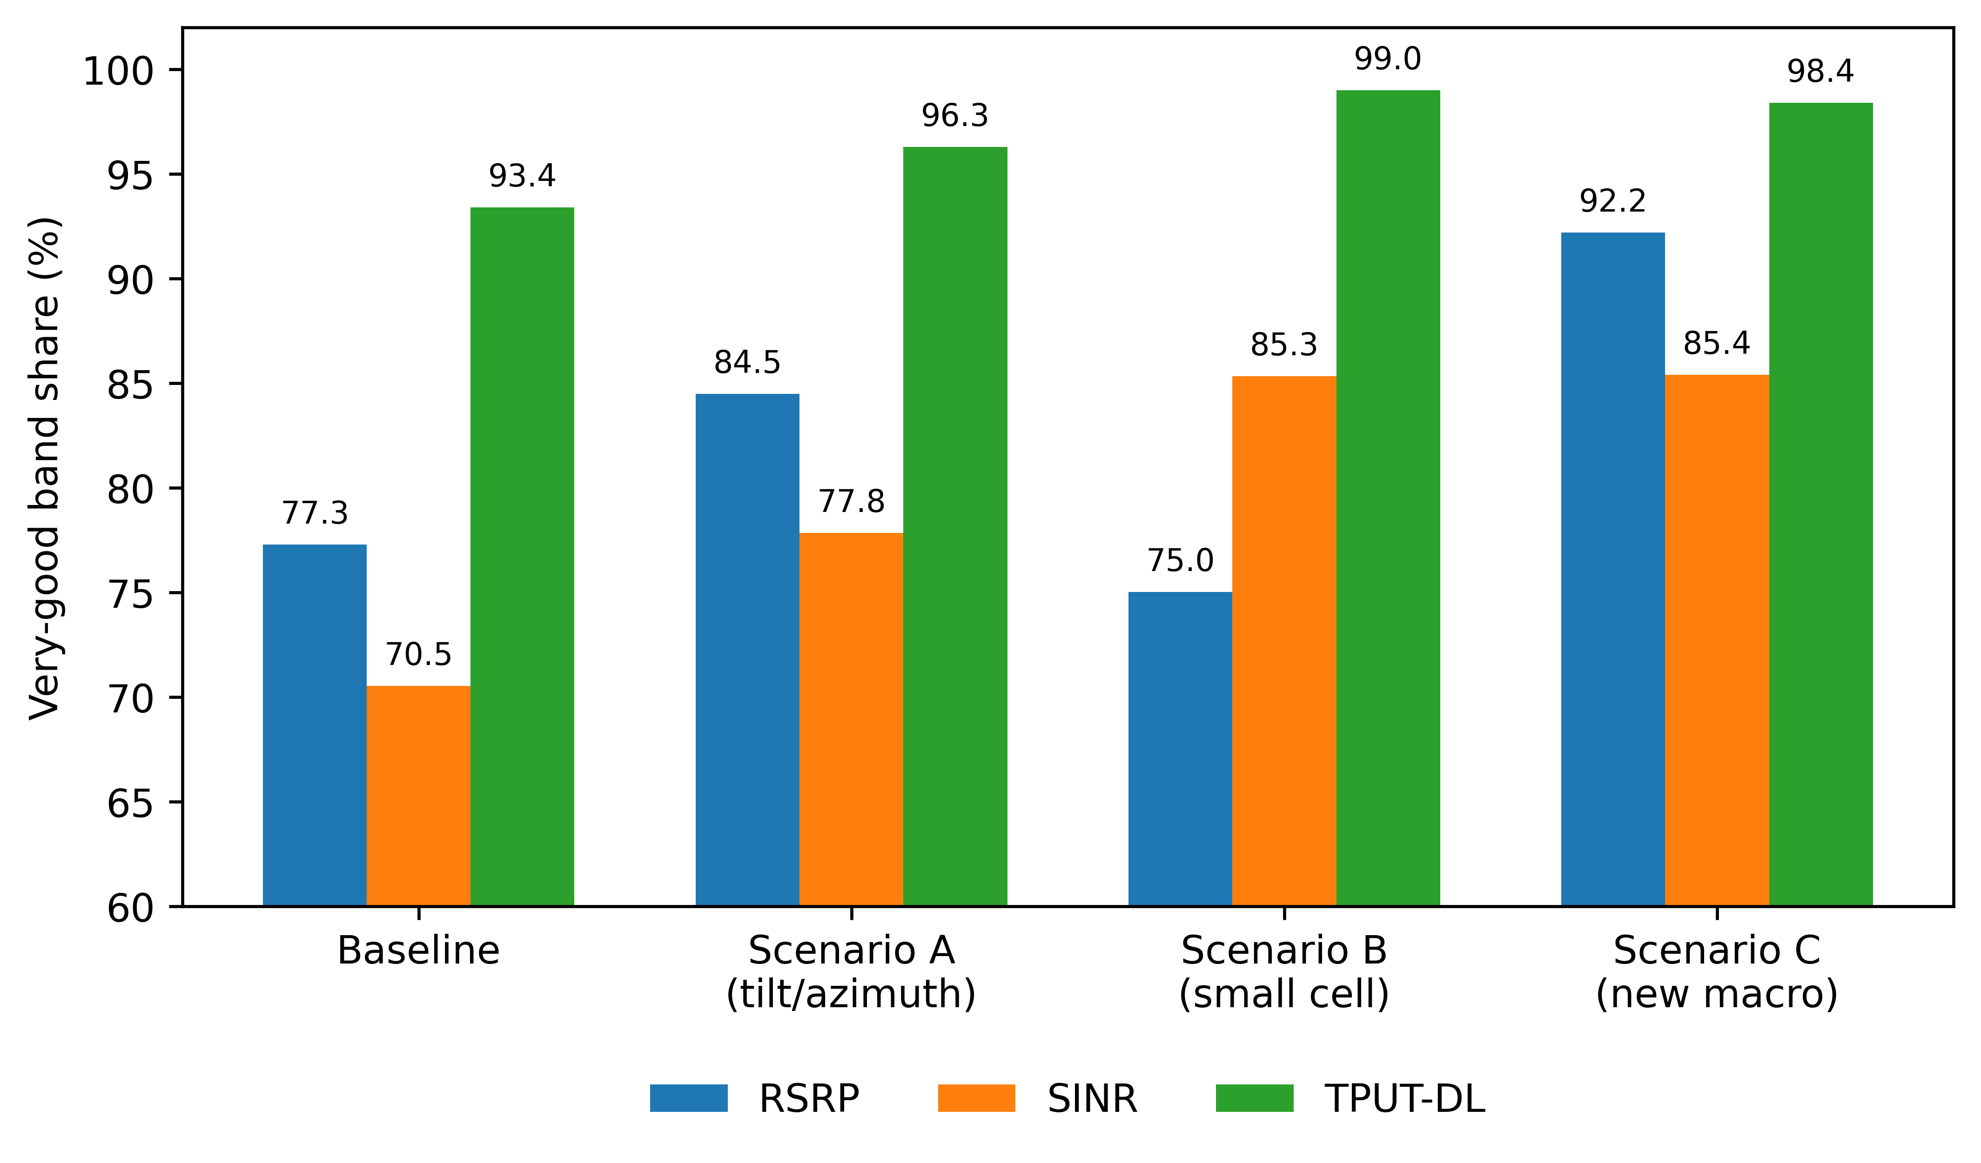
Figure 2 Very-good band share across the Atoll baseline and the three optimization scenarios. Values are model-based area/pixel shares and should not be interpreted as direct predictions of the field sample distribution.
3.4 Hierarchical interpretation and study limitations
Taken together, the results support a staged engineering interpretation rather than a single universally best scenario. Scenario A is the preferred first step because it improved the modeled RSRP, SINR, and throughput distributions without adding site hardware. Scenario B is most attractive when a confirmed hotspot is capacity constrained, whereas Scenario C is most appropriate when residual signal-strength gaps remain after parameter optimization. This sequence is consistent with the broader principle that configuration and interference management should be evaluated before infrastructure expansion [9,13-17].
Several limitations constrain the strength of the conclusions. First, the field dataset represents one operator, two gNodeB service areas, a single measurement period, and only 367 retained 5G-specific records. Second, the field measurement configuration and the Atoll project export are not fully frequency matched. Third, no formal propagation-model calibration was performed, so field-model agreement cannot be expressed as a validated prediction error. Fourth, the Atoll throughput output does not reproduce live traffic contention and should not be directly compared with application-layer field throughput as if both represented the same quantity. Fifth, the hierarchy is ordered by added hardware intensity; the study did not measure CAPEX, OPEX, energy consumption, or lifecycle cost. Finally, the performance-band thresholds are operator-defined categories and may not generalize to other networks.
Future work should repeat the drive test across operators, seasons, times of day, and larger route sets; use geographically aligned measurements for formal propagation calibration; maintain frequency-consistent field and simulation configurations; and incorporate traffic-load, energy, and techno-economic models. These additions would allow the proposed hierarchy to be tested as a quantitatively optimized decision framework rather than as an evidence-based planning sequence.
4. Conclusions
The field measurements show that the Jam Gadang corridor was not primarily limited by RSRP coverage: 97.55% of retained 5G samples were in the very-good RSRP band, while only 0.54% of downlink-throughput samples were very good. The Atoll scenarios indicate different planning roles for the three interventions. Antenna tilt and azimuth tuning improved all modeled KPIs and reduced poor SINR to 0.06%; small-cell densification produced the highest modeled very-good throughput share at 99.00%; and the new macro-site produced the highest modeled very-good RSRP share at 92.20% while eliminating poor RSRP. These results support a hierarchy in which antenna reconfiguration is assessed first, small cells are used for verified capacity hotspots, and new macro-sites are reserved for persistent coverage gaps.
The simulation should be interpreted as a controlled comparative planning model rather than a calibrated replica of the drive-test network. The proposed hierarchy therefore provides a practical engineering sequence, not a quantified cost-benefit claim. Validation with frequency-matched configurations, formal propagation calibration, repeated traffic measurements, and explicit energy/economic analysis is required before the strategy can be generalized beyond the studied corridor.
5. Acknowledgements
Acknowledgements are omitted from the blind manuscript to preserve double-blind review.
6. References
[1] Banafaa MK, Shayea I, Din J, Azmi MH, Alashbi A, Daradkeh YI, et al. A comprehensive survey on 5G-and-beyond networks with UAVs: applications, emerging technologies, regulatory aspects, research trends and challenges. IEEE Access. 2024;12:7786-7826. https://doi.org/10.1109/ACCESS.2023.3349208
[2] Ahamed MM, Faruque S. 5G network coverage planning and analysis of the deployment challenges. Sensors. 2021;21(19):6608. https://doi.org/10.3390/s21196608
[3] Lazar RG, Militaru AV, Caruntu CF, Pascal C, Patachia-Sultanoiu C. Real-time data measurement methodology to evaluate the 5G network performance indicators. IEEE Access. 2023;11:43909-24. https://doi.org/10.1109/ACCESS.2023.3271366
[4] El-Saleh AA, Sharrab Y, Alzyoud F, et al. Measuring and assessing performance of mobile broadband networks and future 5G trends. Sustainability. 2022;14(2):829. https://doi.org/10.3390/su14020829
[5] Imoize AL, Udeji F, Isabona J, Lee CC. Optimizing the quality of service of mobile broadband networks for a dense urban environment. Future Internet. 2023;15(5):181. https://doi.org/10.3390/fi15050181
[6] Kousias K, Rajiullah M, Caso G, Alay O, Brunstrom A, Ali U, et al. Empirical performance analysis and ML-based modeling of 5G non-standalone networks. Comput Netw. 2024;241:110207. https://doi.org/10.1016/j.comnet.2024.110207
[7] Caso G, Rajiullah M, Kousias K, Ali U, Bouzar N, De Nardis L, et al. The chronicles of 5G non-standalone: an empirical analysis of performance and service evolution. IEEE Open J Commun Soc. 2024;5:7380-99. https://doi.org/10.1109/OJCOMS.2024.3499370
[8] Ali S, Abu-Samah A, Abdullah NF, Mohd Kamal NL. Propagation modeling of unmanned aerial vehicle (UAV) 5G wireless networks in rural mountainous regions using ray tracing. Drones. 2024;8(7):334. https://doi.org/10.3390/drones8070334
[9] Sudhamani C, Roslee M, Tiang JJ, Rehman AU. A survey on 5G coverage improvement techniques: issues and future challenges. Sensors. 2023;23(4):2356. https://doi.org/10.3390/s23042356
[10] Bellary A, Kandasamy K, Rao PH. Analysis of wave propagation models with radio network planning using dual polarized MIMO antenna for 5G base station applications. IEEE Access. 2022;10:29183-93. https://doi.org/10.1109/ACCESS.2022.3158948
[11] Haile BB, Mutafungwa E, Hamalainen J. A data-driven multiobjective optimization framework for hyperdense 5G network planning. IEEE Access. 2020;8:169423-43. https://doi.org/10.1109/ACCESS.2020.3023452
[12] Guijarro VRF, Vega Sanchez JD, Paredes MCP, Arevalo FG, Osorio DPM. Comparative evaluation of radio network planning for different 5G-NR channel models on urban macro environments in Quito City. IEEE Access. 2024;12:5708-30. https://doi.org/10.1109/ACCESS.2024.3350182
[13] Qureshi MN, Shahid MK, Tiwana MI, Haddad M, Ahmed I, Faisal T. Neural networks for energy-efficient self optimization of eNodeB antenna tilt in 5G mobile network environments. IEEE Access. 2022;10:61678-94. https://doi.org/10.1109/ACCESS.2022.3181595
[14] Megnafi H, Karaouzene Z, Meriah SM, Merad L. Radio network optimization through antenna tilt adjustment using metaheuristic algorithms and geographic information systems. J Netw Syst Manag. 2026;34(3):65. https://doi.org/10.1007/s10922-026-10051-8
[15] Lempiainen J, Sheikh MU, Asp A, Jantti R. Polarization adaptation to improve cell border area bitrates and system capacity in small cells. Wireless Netw. 2024;30(3):1671-81. https://doi.org/10.1007/s11276-023-03613-0
[16] Ichimescu A, Popescu N, Popovici EC, Toma A. Energy efficiency for 5G and beyond 5G: potential, limitations, and future directions. Sensors. 2024;24(22):7402. https://doi.org/10.3390/s24227402
[17] Abbas WB, Ahmed Q, Khan FA, Mian N, Lazaridis P, Sureephong P. Designing future wireless networks (FWNs) with net zero (NZ) and zero touch (ZT) perspective. IEEE Access. 2023;11:83301-21. https://doi.org/10.1109/ACCESS.2023.3301849
[18] Ali U, Caso G, De Nardis L, Kousias K, Rajiullah M, Alay O, et al. Data-driven analysis of outdoor-to-indoor propagation for 5G mid-band operational networks. Future Internet. 2022;14(8):239. https://doi.org/10.3390/fi14080239
[19] Raftopoulou M, Awan MF, Ramirez-Arroyo A, Saglam MI, Jorguseski L, Drijver F, et al. Deployment and performance evaluation of 5G private networks, enabling use cases in rural remote areas. IEEE Access. 2025;13:154581-98. https://doi.org/10.1109/ACCESS.2025.3603591
[20] Jaensch F, Caire G, Demir B. Radio map prediction from aerial images and application to coverage optimization. IEEE Trans Wireless Commun. 2026;25:308-20. https://doi.org/10.1109/TWC.2025.3583171
[21] Zakeri H, Khoddami P, Moradi G, Alibakhshikenari M, Abd-Alhameed R, Koziel S, et al. Path loss model estimation at indoor environment by using deep neural network and CatBoost for wireless application. IEEE Access. 2024;12:159070-85. https://doi.org/10.1109/ACCESS.2024.3487118

